**CHAPTER I**

**INTRODUCTION**

**Background of the Project**

Numerous nations presently utilize public video surveillance cameras as an essential tool to screen populace occurrences, developments, and prevention of crime and terrorism, both within the private and public sectors. Facial Recognition technology is now a developing and common in a growing number of places around the globe, countries such as the US, China, India, Singapore, United Arab Emirates and many more countries are utilizing and improving this technology. In India facial recognition is used for crime related incidents mostly missing person/children cases. The US is planning to utilize facial recognition technology in their airports by the year 2021. China is currently using the technology in their schools to monitor student behavior and record the attendance. In July 2019 a South China Morning Post reported that China is currently working on the world’s most advanced and powerful face recognition technology that is able to detect and identify any of their 1.3 billion population within 3 seconds. (Radu, 2019)

A study entitled Motion Detection and Face Recognition for CCTV Surveillance System where Haar Cascade Classifier is used for face segmentation, and uses three algorithm for face extraction and training namely Speed-Up Robust Features (SURF), Principal Component Analysis (PCA), and Counter Propagation Network (CPN) obtained a face detection success rate of 76% and face recognition success rate of 60%. Whereas our study which uses the same Haar Cascade Classifier for face detection and Local Binary Pattern Histogram for training model and face recognition creates an improvement in terms of face detection and face recognition success rate primarily because of the use of LBPH paired with Haar Cascade Classifier. Another study Face Recognition-based Real-time System for Surveillance which has features of access control to secure environments, identification of individuals at a particular place, and intruder detection used the same algorithm for face detection and face recognition as the first stated study. This indicates that Principal Component Analysis (PCA) paired with Haar Cascade Classifier achieves acceptable face detection and face recognition rate. Compared to the mentioned previously published studies the use of Haar Cascade Classifier paired with LBPH shows improved results.

The purpose of this project is to fill in the surveillance camera’s shortcomings; Today, universities and colleges are seeking technological innovation to re-open their campuses safely for the already started school year; This will be a challenge for everyone, that is why a solution is needed; with the system that is being proposed trying to provide a better way to monitor, identify and give better security to each and every student, teachers, and staff of Western Mindanao State University campus with hygienic, seamless and preferably touch less, high-assurance identity management.

The proposed system "Enhance Security Monitoring using Real-time Face Recognition System with Haar Cascade Classifier and Local Binary Pattern Histogram for Western Mindanao State University" will bring new technology and upgrades to surveillance cameras and add new capabilities. This study aims to enhance and improve the security and log management of Western Mindanao State University by integrating facial recognition technology in the school’s main campus gate.

**Statement of the Problem**

Outdated security measures of WMSU are insufficient to monitor each individual entry to the school premises and the currently used log system is taken manually with pen and paper which causes time and paperwork. Face Recognition having the ability to monitor and log each entry makes it easier and convenient for visitors, students and employees to enter the school premises with ease. This project is established to improve Western Mindanao State University's security and upgrade the currently used log in system of the school. For a large university, security personnel are not enough to secure the number of people who come in and out of the school premises; therefore, the addition of a facial recognition system would be implemented to improve the existing security measure.

**Objectives**

General:

This project's general objective is to develop a system that implements public security through the use of Facial Recognition in the Western Mindanao State University Campus main gate. Specifically, this project sought to achieve the following objectives:

Specific:

● Develop a facial recognition system that is capable of storing and recording the facial image with personal information of students, faculty, staff and other Western Mindanao State University associates.

● To achieve facial recognition with an acceptable confidence rate up to 92% for a reliable and functional facial recognition system.

● Develop a facial recognition system for Western Mindanao State University using Haar Cascade for face detection and Local Binary Pattern Histogram for face recognition.

● To create a facial recognition system with automatic log management feature to aid the security officers of Western Mindanao State University in detecting authorized and unauthorized personnel entry.

● To promote an alternative way of log management for Western Mindanao State University students and employees using facial recognition technology.

● To prevent any crime related incidence by monitoring registered and unauthorized individuals.

**Scope and Limitations**

The projects Scope are as follows:

● Administrator - Can log in into the system and do the following features; register face, search person information and log management, remove a registered face from the system.

● Students, Faculty, and Staff - The students, faculty, and staff of WMSU must register their faces and basic information in the system.

● Training Classifier – can train the classifier for newly registered individuals

● Face Detection – The system can detect faces of individuals in real-time and simultaneously.

● Generate Dataset – register new individuals in the system.

● Face Recognition – recognize and identify registered individuals in the system.

● Unauthorized Detection – detects unknown or unregistered individuals.

● Automatic Log Feature – records name, date and time if the system recognize the person.

The projects limitations are as follows:

● May not be able to scan individuals wearing helmets, masks, hijab and other face garments that might cover important face features.

● May not recognize unregistered individuals.

● Requires personnel to train newly registered individuals

● Requires personnel to monitor the operations of the system

● May not be able to scan individuals 2 meters away from the camera.

● For the system to recognize the person’s face, all important face feature like eyes, nose and mouth must be visible in the camera feed.

● This study is limited only to WMSU employees and students.

● Desktop app are set-up in entry and exit points.

**Significance**

This study is constructed to evaluate the effectiveness of instigating a facial recognition system at the Western Mindanao State University campus gates.

Benefitting this system are the various sectors as follows:

● Student - All students of WMSU are required to register their faces in the system. The registered faces will then be used to track the individual in and out time at the school campus.

● Employee - All employees of WMSU are required to register their faces in the system, for it will be used to track every individual's time in and time out on the school campus.

● WMSU Security Officers - The implementation of this system will be beneficial to security officers of WMSU, for it will be used in monitoring crime-related circumstances inside the school campus.

● Parents - The parents of the students will also benefit from the implementation of this system, for they will be assured that their children are safe. The WMSU management office can also use the data to inform parents if their child is attending school or not.

● Future researchers – The data and idea of the project may be used as a reference in developing new systems related to computer vision and facial recognition; the data presented can also be used in testing the validity of related studies and serve as their cross-reference that will help them develop new innovative systems.

**Theoretical Framework**

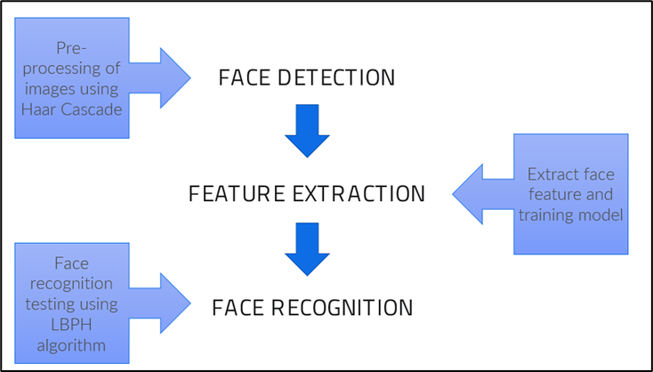

**Operational Definition**

Table 1: Operational Definition

| **TERM** | **DEFINITION** |
| --- | --- |
| Facial/Face Recognition | A biometric software application capable of distinctively verifying or identifying a person by analyzing and comparing patterns based on the person's facial shapes is referred to as face recognition. |
| Face Detection | Face detection lets you find the location (pixel coordinates) of any faces in an image. |
| Face Extraction | A neural network takes an image of the person's face as input and outputs a vector that represents the essential features of a face. |
| Image Acquisition | Image Acquisition is the first stage of any vision system that refers to the collection of data required to form an image. |
| Training image | The training process involves finding a set of weights in the network that proves to be good, or good enough, at solving the specific problem. |
| Face Database | Database containing student and employee face |
| Face embedding | Face embedding is a vector that represents the features extracted from the face. |
| Confidence rate | Refers to a scale that describes how certain a facial recognition system that a match it has produced is accurate. |
| Haar Cascade | This refers to an Object Detection Algorithm used to identify faces in an image or a real time video. The algorithm uses edge or line detection features proposed by Viola and Jones. |
| Local Binary Pattern Histogram (LBPH) | This refers to a face recognition algorithm based on a local binary operator, designed to recognize both the side and front face of a human. |

# 

# 

# 

# 

# 

# 

# 

# **CHAPTER II**

**REVIEW OF RELATED LITERATURES AND STUDIES**

The review of related literature is created to provide a summary of existing research or studies related to this project. This chapter contains the related literature and related studies.

## **Related Literature**

CCTV

CCTV's were first invented and used in Germany. It was a system developed to monitor the country's V-2 rockets. Until people realized its usefulness, it was launched commercially in 1949 for the public. Years have passed from the time it was invented, and CCTV's evolved into state-of-the-art equipment with several applications in many businesses and homes during this period.

According to Koorsen Fire & Security, CCTV is everywhere these days. You'll find them in pretty much every bank, school, hospital, and business of every size, even in many homes. Wherever you find them, they act as an extra eye for whenever people are not around. They are there to prevent crime, monitor the environment, and, most importantly, record video footage that may be important. What does CCTV mean, and How does it work? Closed Circuit Television (CCTV) or simply Video Surveillance Systems are unique cameras that people use to monitor security and other reasons. For the CCTV to work, it must have these four parts; cameras, recording devices, monitors, and video management software. (Koorsen Fire & Security , 2021)

Schools these days are also implementing the use of CCTV to benefit from its usefulness, whether campus security, attendance system, automated registration, and emotion detection.

Facial Recognition

According to a study by Parekh Payal and Mahesh M. Goyani, Face Recognition identifies and verifies faces. Face recognition has vast importance in Security, Healthcare, Banking, Criminal Identification, Payment, and Advertising. The study determines various challenges and techniques for face recognition. Challenges such as illumination, pose variation, facial expressions, occlusions, aging, etc., are the critical challenges to face recognition. The methods used for facial recognition to work are pre-processing, Face Detection, Feature Extraction, Optimal Feature Selection, and Classification are the primary steps in any face recognition system. The study also states that facial extraction is the most crucial stage for any facial recognition system to work and the deep learning method helps the user by freeing them from handcrafting the features. (Payal & Goyani, 2020)

Another study by Serign Modou Bah and Fang Ming states that a lot of development has been made in the area of facial recognition and detection for security, identification, and attendance purposes. Still, it turns out that there are still issues that hinder progress from reaching or surpassing human-level accuracy. These issues are varieties in human facial appearance such as; changing lighting condition, clamor in confront pictures, scale, posture, etc. With these challenges to consider, the researchers of this study used another method by using Local Binary Pattern (LBP) algorithm combined with advanced image processing techniques such as Contrast Adjustment, Bilateral Filter, Histogram Equalization, and Image Blending. These solve some of the issues hampering face recognition accuracy to improve the LBP codes, thus improving the accuracy of the overall face recognition system. (Serign & Ming, 2019)

Neural Network

In a research done by Naoyuki Kubota (2011) titled “ Applying Artificial Neural Networks for Face Recognition” in the process of identifying or analyzing the facial land points the researcher used hybrid model combining AdaBoost and Artificial Neural Network (ABANN) to improve the efficiency of facial recognition; the system consist of four modules : detection, alignment, feature extraction, and matching ; The research done by Naoyuki Kabuto provides some basic neural network models and efficiently applies these models in modules of face recognition system. For the face detection module, a three-layer feedforward artificial neural network with Tanh activation function is proposed that combines AdaBoost to detect human faces so that face detecting rate is rather high. (Kubota, 2011)

The Naoyuki Kubota facial recognition with neural network basically uses three-layer feedforward artificial neural network and AdaBoost for detecting human faces which in comparison with traditional technique shows higher identifying and detecting rate.

While in a research done by Juan Pablo Balarini, Sergio Nesmachnow and Martín Rodríguez of Universidad de la República, Facultad de Ingeniería titled “ Facial Recognition Using Neural Networks over GPGPU'' they introduce the use of parallel neural network approach which also use the processing power of Graphic Processing Unit (GPU); in their studies the three researcher thought that the efficiency of Neural network processing image in detecting facial points would be effective and efficient with the help of GPU which they stated that “GPU implementations allow obtaining significant reduction in the execution times of complex problems when compared with traditional sequential implementations on CPU” and with the use of sequential algorithm by Shufelt and Mitchell for recognizing if a given picture is of a certain person. (Balarini, Nesmachnow, & Rodríguez, 2012)

The method of Naoyuki Kubota slightly improve the analyzing process with the use of hybrid model and combing AdaBoost and Artificial Neural Network for detecting and matching face; but in the test experiments in prove that AdaBoost and ANN approaches for detecting faces do not achieve good results of performance time and detecting rate yet;

While the research done by Juan Pablo Balarini, Sergio Nesmachnow and Martín Rodríguez of Universidad de la República have a much better outcome with significant reduction on computing times can be obtained allowing solving large instances in reasonable time. Speedup greater than 8 is achieved when contrasted with a sequential implementation and classification rate superior to 85 % is also obtained.

Deep Learning

Deep Learning is a subfield of Machine Learning which uses a ‘layered’ architecture to learn representations. Each successive layer in the layered architecture works with more meaningful and sophisticated representations; in a research done by Diego Andina (2017) titled “Deep Learning for Computer Vision” he talks about how deep learning evolve in short span of time according to Diego Andina “Deep learning methods have been shown to outperform previous state-of-the-art machine learning techniques in several fields, with computer vision being one of the most prominent cases” which is correct from unlocking your smartphone to facebook improve tagging system; deep learning really evolve on how computer interpret and analyzing data, in his research he stated that Deep learning allows computational models of multiple processing layers to learn and represent data with multiple levels of abstraction mimicking how the brain perceives and understands multimodal information. (Andina, 2018)

The researcher Diego Andina also indicates that there are 4 most significant deep learning schemes used in computer vision problems, that is, Convolutional Neural Networks, Deep Boltzmann Machines and Deep Belief Networks, and Stacked Denoising Autoencoders which can be used for system like object detection, face recognition, action and activity recognition, and human pose estimation.

In a research done by Md Nazmus Saadat and Muhammad Shuaib (2020) titled “ Advancements in Deep Learning Theory and Applications: Perspective in 2020 and beyond “ the researcher talk how deep learning works; the researcher stated that there are two types of machine learning ; first is the supervised learning, the machine can only give you correct output when the input is already experienced in training phase; it is based on experience; the more is the training dataset or experience of your machine the higher is the chances of getting the actual output, and the second is unsupervised learning, supervision of a model is not needed, rather the model work on its own catches new data and discovers the information inside the data. It usually deals with label-less data; compared to supervised learning, unsupervised learning is more complicated. It is usually used to find features and unknown patterns. (Saadat & Shuaib, 2020)

## 

## 

## **Foreign Studies**

Motion Detection and Face Recognition for CCTV Surveillance System

According to this study the use of CCTV throughout the years evolved from simple surveillance of home, workplace, and private properties into an intelligent control device. This studies CCTV video processing has three outputs: face detection information, motion detection information, and face identification information. Accumulative Difference Image or ADI was used for motion detection, and Haar Classifiers Cascade was used for facial segmentation. To extract features this study made use of Speed-up Robust Features or SURF and Principal Component Analysis or PCA. Counter-Propagation Network or CPN is used to educate the features. The study used 45 CCTV videos and all of 45 videos were subjected to offline checks. The studies test results show a 92% success rate for motion detection, 76% success rate for face detection, and 60% success rate face identification. According to the findings the study concludes that using CCTV video with a natural context for face detection did not achieve optimum resolution while the motion detection method is preferable to use in real-time situations. (Nurhopipah & Harjoko, 2018)

Face Recognition-based Real-time System for Surveillance

According to this research paper the ability to automatically recognize human faces based on dynamic facial images is important in security, surveillance and the health/independent living domains. Specific applications include access control to secure environments, identification of individuals at a particular place and intruder detection. This research proposes a real-time system for surveillance using cameras. The process is broken into two steps: (1) face detection and (2) face recognition to identify particular persons. For the first step, the system tracks and selects the faces of the detected persons. An efficient recognition algorithm is then used to recognize detected faces with a known database. The proposed approach exploits the Viola-Jones method for face detection, the Kanade-Lucas-Tomasi algorithm as a feature tracker and Principal Component Analysis (PCA) for face recognition. This system can be implemented at different restricted areas, such as at the office or house of a suspicious person or at the entrance of a sensitive installation. The system works almost perfectly under reasonable lighting conditions and image depths. (Fahad , Habib, Vasant, Mckeever, & Ahad, 2016)

This research paper is related to our study for it tackled the use of CCTV in implementing facial recognition systems at different restricted facilities, such as workplaces, houses, and schools. The study also aims to use the system for crime monitoring and prevention and detection of suspicious individuals, which is the same objective that our research has.

## **Local Studies**

Student Monitoring System of Our Lady of Fatima University Using Face Recognition

This research paper concludes that the rapid development of face recognition is due to a combination of factors: active development of algorithms, the availability of large databases of facial images, and a method for evaluating the performance of face recognition algorithms. The system covers any departments, agencies or companies which require personal identification and security to their employees. The face recognition system covers multiple face photos, matching of faces, head rotations, detects 66 facial feature points (eyes, eyebrows, mouth and nose) and all data are placed in a database. Additional enrolments will be required upon various changes in registered faces. The said system only limits personal identification which contains certain fields about the registered user, it cannot detect the skin color and age of a person and the system is not a video- based face recognition system. This system does not expect to solve all the issues in face recognition, such as extreme facial expression, wearing on the face, great age discrepancy and extreme lightning condition and without frontal face information. (Alolor, et al., 2014).

**Synthesis**

All the mentioned studies above have one common purpose and that is to achieve a facial recognition feature with acceptable confidence rate. The research studies differ only in the approach on how to achieve facial recognition. In creating a facial recognition system it is not only the facial recognition that is important there are other factors as well such as how to detect face and how to extract features of the face the quality and number of the datasets needed. The researchers of this study developed a system that is able to detect faces of the subject effectively, extract features of the face and finally facial recognition with high enough confidence value. This system is developed to provide Western Mindanao State University a monitoring and log management system.

The three related studies mentioned above utilized the same algorithms for face detection, the haar cascade algorithm. For face detection the studies used a different approach which gives different results upon the effectiveness and accuracy of face recognition. With this the researchers of this study decided to use haar cascade for face detection and paired it with another face recognition algorithm that was not used by the mentioned related studies. The algorithm used for face detection in this study was Local Binary Pattern Histogram LBPH. The researchers have found out that using much higher pixel size training images of each subject and with much better parameter value of haar cascade algorithm paired with LBPH results in much higher accuracy and stability in developing the system.

**Technology Gap Analysis**

Historically, security systems at Western Mindanao State University (WMSU) have consisted of a handful of critical components. These include well-trained personnel and a CCTV system. Occasionally, the typical security system components are sufficient for special purposes. Nonetheless, there is no denying that these types of security systems have inherent flaws that more advanced and sophisticated systems are more than capable of overcoming.

Recently, the campus integrate a new method of log and identification in the school gates using Radio Frequency Identification (RFID) in students/employee ID, though this might be a good solution but It takes an additional step when entering the school premises, through the development of Face Recognition for more enhance security and better log management system this is set to overcome the weakness of the traditional security system of the campus.

Various face attendance system also already exist like the “Motion Detection and Face Recognition for CCTV Surveillance System” by Nurhopipah & Harjoko, 2018, their study shows good result in detecting motion in surveillance camera reach the confidence rate of 92%, but the face recognition part of the system only reach up to 60% , similarly (Alolor, et al., 2014) also developed a system called “Student Monitoring System of Our Lady of Fatima University Using Face Recognition” the system where able detects 66 facial feature points (eyes, eyebrows, mouth and nose) and all data are placed in a database but their system is not a video- based face recognition system.

**Comparison Table of Related Studies**

| **System** | **Image**  **acquisition**  **from**  **video frame** | **Face**  **Detection** | **Face**  **Recognition** | **System**  **Alarm for recognized and unrecognized individuals** | **Automatic Log feature** | **Face**  **Registration** | **Video log history** | **Record log with date and time** |
| --- | --- | --- | --- | --- | --- | --- | --- | --- |
| **ENHANCED SECURITY AND LOG SYSTEM FOR WESTERN MINDANAO STATE UNIVERSITY (WMSU) USING REAL-TIME FACE RECOGNITION SYSTEM** | ✔ | ✔ | ✔ | ✔ | ✔ | ✔ | ✔ | ✔ |
| **Face Recognition**  **Based**  **Automated Student**  **Attendance System** | ✔ | ✔ | ✔ |  | ✔ | ✔ |  |  |
| **FacePro:**  **Panasonic Facial**  **Recognition**  **System** | ✔ | ✔ | ✔ | ✔ |  | ✔ |  |  |
| **Face Recognition**  **Security System** | ✔ | ✔ | ✔ | ✔ |  | ✔ |  |  |
| **Applock (Android**  **App)** |  | ✔ | ✔ |  |  |  |  |  |

The table above shows the comparison of features of the systems. This is the list of systems that are similar to our system in terms of main purpose which is facial recognition and detection. As shown in the table the facial recognition system for WMSU was able to dominate other existing systems in terms of features. With the 8 features listed the study’s system is able to perform all the features.

**CHAPTER III**

**METHODOLOGY**

**Research Design**

This study is conducted mainly for the purpose of providing Western Mindanao State University a face recognition biometric for log record of entry in the school premises. The Subject's face is used as a dataset and utilized using Haar cascade algorithm for face detection and Local Binary Pattern Histogram for face recognition.

The study will be using the applied research design method. The method is chosen to determine the applicability and effectiveness of Haar Cascade and Local Binary Pattern Histogram for enhancing school security monitoring and log record management. During the development process the researchers will follow the iterative model for the software development:

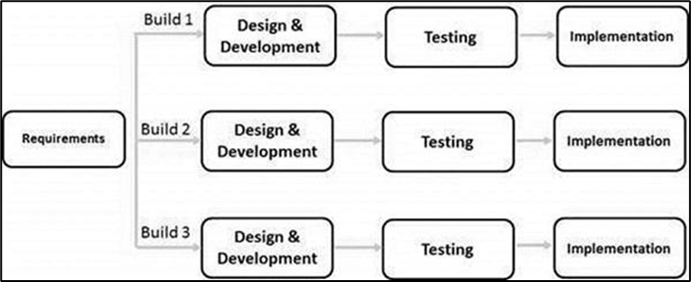Figure 5: SDLC Iterative Model

Phase #1: Planning and Requirements: In this stage, the researcher will map out the initial requirements, gather the related documents related to face recognition and neural network, and create a plan and timeline for the first iterative cycle.

Phase #2: Analysis and Design: in this phase the researcher will finalize the requirements needed, the database models, and technical requirements based on the plan. Then create working architecture, schematic, or algorithm and install all the required library and development tool that satisfies the requirements.

Phase #3: Implementation: The researcher will start developing the functionality and design required to meet the specifications of the system.

Phase #4: Testing: the researcher will identify and locate what’s not working or performing to expectations.

Phase #5: Evaluation and Review: Compare this iteration with the requirements and expectations.

After the completion of these steps or processes, it’s time to tackle the next cycle. In this process, the product goes back to step one to build on what’s working. Identify what the researcher learned from the previous iteration. This iterative development, sometimes called circular or evolutionary development, is based on refining the first version through subsequent cycles, especially as you gather and include requirements. It allows the development to remain flexible as the researcher identify new needs or unexpected system issues.

## **Respondents**

This study requires a number of respondents to test effectiveness of the system in terms of implementation. The respondents of this study must be WMSU employees, faculty staff, and students for they will be the main subject of this research. To minimize the population of WMSU the researchers select the respondents by picking one college department from the cluster of colleges in WMSU.

The College of Computing Studies was selected as respondents for this study. To select respondents from CCS a simplified random sampling method was used. These randomly selected respondents consist of the faculty members and students of CCS.

## **Research Instrument**

The study aims to determine the effectiveness of facial recognition as a biometric to record log of entry in the school campus using Haar Cascade paired with Local Binary Pattern Histogram algorithms.

The researcher is required to gather a set of data needed to be inputted into the system like the individual’s basic information (Names, Student ID, Course, Types) and their face features. Face is the primary data of this study, face features will be converted into histogram to store it in the system.

The first procedure to acquire and prepare the data sets are by portrait acquisition; during this method the system must 1st sight the presence of the face within the webcam; one individual only needs one (1) portrait to be used as data sets, after detection and capturing portrait it will proceed to pre-processing procedure to get BGR image and cropped faces of equal sized pictures.

**Data Gathering Instruments, Techniques, and Procedures**

### **Image Acquisition**

The Face Recognition system will obtain 200 images per person by interfacing a webcam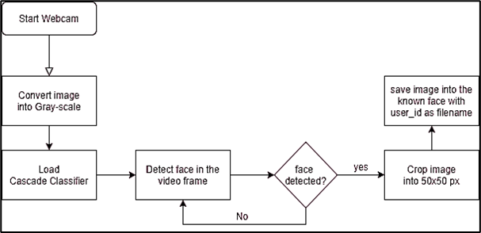

Figure 6: Image Acquisition Flow Chart

The above flowchart shows the data gathering procedure during image acquisition phase; this will allow us to prepare the datasets to be used for the next process.

### **Datasets Acquisition**

A data set is created by taking images from a camera or images that are already saved, and then creating a unique identifier in each images such as name, age, profession etc. Images with unique identifier will then be transferred to the database. It is recommended to take many sample images from a single person for these samples will be used for training algorithm and testing. Local Binary Pattern works by using 3 by 3 blocks of pixel in an image, each pixel has a value ranging from 0 to 225.

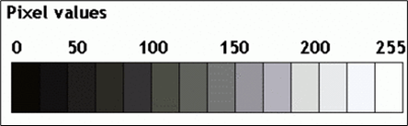

This shows a block of an image with 3 rows and 3 columns for a total of 9 pixels. The central value of this block is called the threshold and the surrounding values are its neighbour. To get the necessary calculations for the LBP the researcher will compare the threshold to its neighbours with the condition: If threshold is greater than or equal to its neighbour the neighbour’s value will be changed to 1 hence it will be changed to zero.

This calculations will be then change into binary number excluding the threshold starting from the top left corner element followed by the element of the second row creating a circular pattern up to its last element. This will give a binary value of 11100010.

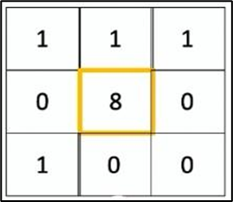

The binary value will be then converted into decimal value which then indicates that the 3 by 3 block of pixels is around the central value of 266.

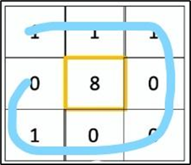

Output Value of LBP Operator

LBP = ∑n=0 S( in - ic) 2^n

S(z) = 1 if z ≥ 0

0 if z > 0

Where, in = Center pixel value

Ic = Neigbour pixel values

The above formula is the proper formula to get the value in binary of the pixels surrounding the center pixel. If all neighbour pixels are converted into binary they will be computed to get the decimal value for the LBP operator.

The last step in the LBPH is to create a histogram which indicates how many times a color appears in each square. This is how the algorithm identify edges, borders and corners of an image. With this process the algorithm knows which histogram indicates the color of the eyes, the lips, and the mouth and so on. The binary value will be then converted into decimal value which then indicates that the 3 by 3 block of pixels is around the central value of 266.

## **Entity Relation Diagram (ERD)**

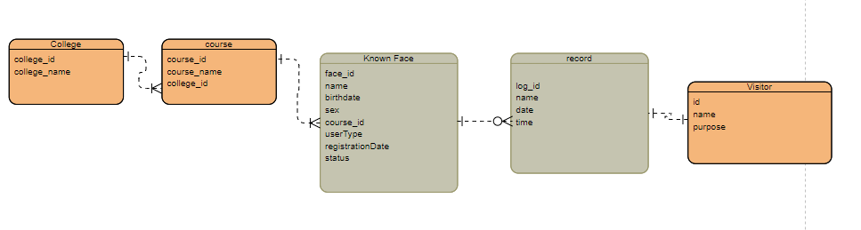

## **System Use case Diagram**

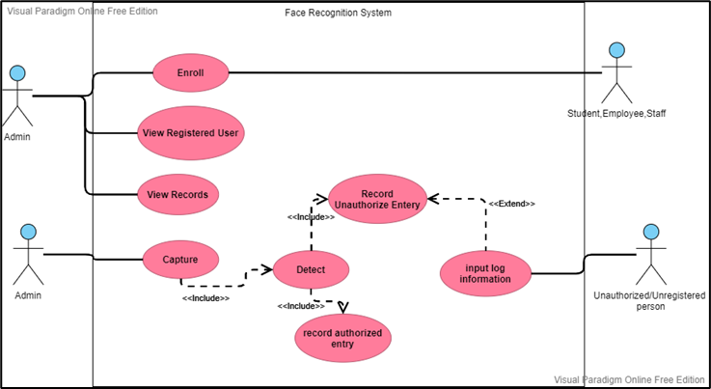

Figure 4: System Use case Diagram

Figure above shows the steps of the transaction using the system. The subjects (students, employee, staff) will enroll their face in the system and the date for each subject will be stored, the system will then recognize their entry and create a log stating the time and date of entry. For unenrolled subjects they will also be recognized by the system as unregistered individuals.

**Statistical Tool**

In this study, the researchers made use of two algorithms namely Haar Cascade for face detection and Local Binary Pattern Histogram for face recognition. These algorithms are utilized to detect faces as well as collecting face data and convert it into a histogram to store in the system. Every registered face in the system will have information such as name, age, course, college, birthdate, and sex. The researchers selected these two algorithm as these algorithm provide best results in terms of detection speed and accuracy, and facial recognition speed and confidence rate.

**Algorithm**

**Haar Cascade Classifier**

Haar cascade is used for the detection of faces in this study. Haar Cascade is an object detection algorithm designed to identify faces in an image or a real-time video. This algorithm is very popular and is widely used worldwide. Haar cascade is used in mobile applications and surveillance security and biometrics. The algorithm is trained by first giving it positive images which consist faces of different individuals and negative images not consisting any face. In this method the algorithm will differentiate and learn which a face is and which is not.

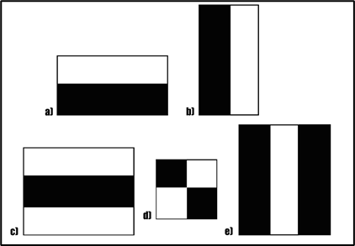

Figure 7: Haar-like Feature

Haar cascade works by using the figures above. All of these features are use in a single image to locate a particular feature of the face like the eyes, nose line, lips etc. These features are necessary to collect data from image; these data are gathered from every pixel of the image using these features. When all of these features are implemented in an image it would sum up approximately 180,000 features. Some of these features are irrelevant or not necessary examples are the hair and the foreheads. Haar cascade only needs important facial feature such as eyes and nose line and in the 180,000 features most of the features are unnecessary therefore AdaBoost is used to eliminate the unnecessary features.

Haar cascade is one of the oldest but tested and powerful facial detection algorithms. The algorithm is used in this thesis for it is a tested and an algorithm that proves its effectiveness for a long time. Not only facial feature detection but Haar cascade is also used in plate number detection etc. Haar cascade is also very compatible with Local Binary Pattern Histogram which makes an acceptable confidence rate.

### **Face Recognition Local Binary Pattern Histogram**

LBPH or Local Binary Pattern Histogram is a face recognition algorithm based on a local binary operator designed to recognize both the front and side of the human face. Facial Recognition is a technology that is used to recognize a person from a video or image and then linking to a particular person. Facial Recognition is different from facial detection. Facial Detection is the ability to identify human faces from video or an image, which is therefore used for facial recognition.

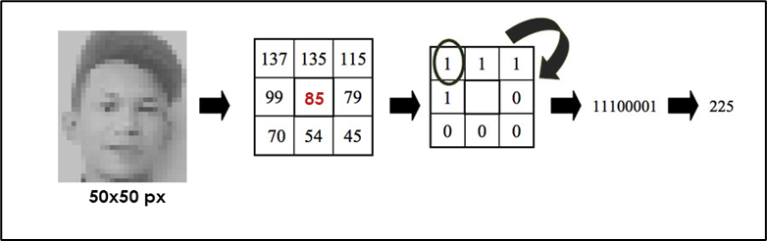Figure 8: Image Pixel Conversion to Binary Number

Local binary operator is used for every region. The LBP operator is defined in a window of 3x3 and repositions it across a single image. At each step (each small section of the image), compare the pixel in the center to its neighbors. Indicate by 1 the neighbors with an intensity value less than or equal to that of the center pixel, and by 0 the neighbors with an intensity value greater than or equal to that of the center pixel.

## **Training**

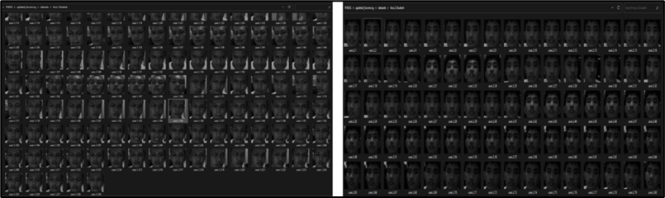

Figure 9: Training Images Captured Using Haar Cascade

To achieve the maximum accuracy required, the system requires to generate at least 250 training images using a haar cascade frontal face; the training images must be 300x300 pixel value and reduce the RGB to grayscale images.

**System Architecture**

## The system consists of a face detection module which detects face(s) in each frame, and a face recognition module which identifies detected face images from detection module as a name or identity number. The overall architecture of a Complete Face Recognition System is shown in the following figure.

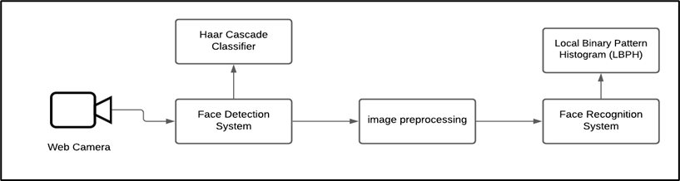

| *Figure : System Architecture* |
| --- |

## **System Block Diagram**

System Block Diagram i.e. fig.1 below served as framework of the system. The Camera module is the main component of the system. When the system is turned on, the camera module will capture image frames if face is detected it would crop the face and pre-process the image using OpenCV library and extract the face feature using LBPH then it would output weather the detected face is registered or unregistered.

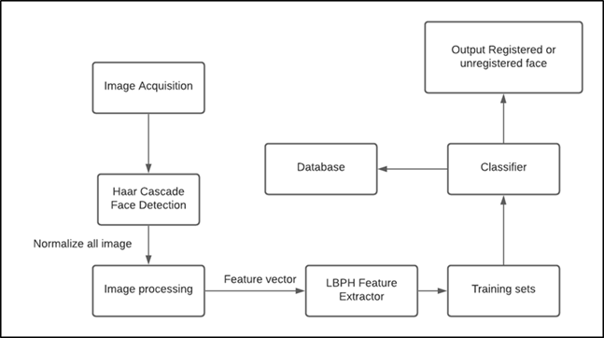

Figure 2: System Block Diagram

|  |
| --- |

### 

### 

### 

### **Implementation**

### **Hardware during development**

CAMERA : Redragon HITMAN webcam

CPU : Ryzen 5 5500

RAM : 8gb

Storage : 1TB SSD

**System Requirements**

**OPERATING SYSTEM :** Windows 7 (64-bit) version later.

**CAMERA** : 1080p CCTV or Web Camera

**CPU** :Intel or AMD processor with 64-bit support, 2 GHz or faster processor.

**RAM** : at least 4GB

**Storage** : 1TB SSD

## **Development Tools**

## **IDE**

● Visual Studio Code

● PyQT5 Designer

## **Programming Language**

● Python

● PHP

**LOCAL WEB SERVER**

● XAMMP - is a free and open-source cross-platform web server solution stack package developed by Apache Friends, consisting mainly of the Apache HTTP Server, MariaDB database, and interpreters for scripts written in the PHP and Perl programming languages.

## **Libraries forDevelopment**

● cycler==0.10.0

● kiwisolver==1.3.2

● matplotlib==3.4.3

● mysql-connector==2.2.9

● numpy==1.21.2

● opencv-contrib-python==4.5.3.56

● opencv-python==4.5.3.56

● pandas==1.3.3

● Pillow==8.3.2

● pyparsing==2.4.7

● PyQt5==5.15.4

● PyQt5-Qt5==5.15.2

● PyQt5-sip==12.9.0

● PySide2==5.15.2

● python-dateutil==2.8.2

● pytz==2021.3

**Network Requirements**

● The Client-side must been connected on the same network as the server.

**CHAPTER IV**

**RESULTS AND DISCUSSIONS**

This section shows the results of system implementation testing and discussing its functionality and capability.

The proposed thesis, entitled "Enhanced Security Monitoring and Log System for Western Mindanao State University using Real-time Face Recognition System," makes use of the Local Binary Pattern Histogram (LBPH) algorithm for face recognition, and Haar Cascade for face detection over a Red Dragon HD web camera. The system operates by following these processes.

First obtaining a dataset of facial images, second training the dataset, and third performing facial recognition. In the facial image dataset acquisition process, a subject's face is scanned using the camera to register the subject's facial dataset in the system. Every subject is captured a total of 250 images upon registering their facial image in the system, and during this process, the subjects are assigned a unique ID along with their information such as name, course, etc. These 250 images of every subject will then go through a process called dataset training, where the LBPH algorithm is used to create a unique histogram of each and every registered subject. After a successful Face Registration to the system the newly registered subject will be scanned again for face recognition, if the subjects face is successfully recognized the system these ends the process of registering and face recognition.

## **Face Enrolment**

Figure 10: Face Enrolment Real-time Generation Speed

Face Enrolment is the first process of the system. A web camera module is used to detect the face of the subject using the Haar cascade algorithm and then capture 250 images per subject. Upon testing, it took 34.616213 seconds to generate 250 images of a subject for registration.

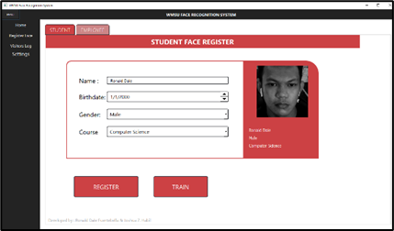

*Figure 11: Face Registration UI*

Face Enrolment for students requires basic information like name, birthdate, gender, and course; for employees, the registration information requires name, birthdate, gender, department, employee type, and position. During the enrolment process, the system will then assign the subject a face ID to be able to uniquely identify the subject's face.

This test proves that the system has the capability of storing and recording facial images with personal information of each subject to be used for face recognition.

## **Training the Classifier/Dataset Training**

**

*Figure 12: Training time with only 1 registered subject*

**

Figure 13: Training time with 2 registered subjects

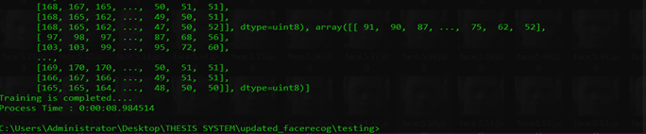

Figure 14: Training time with 3 registered subjects



Figure 15: Training time with 4 registered subjects

Training classifiers or dataset training is a process where the captured 250 images is trained to create a unique identification per subject. The ID of each unique subject will be used for the face recognition process.

Table 2: Training Classifier

| Training Classifier | | | |
| --- | --- | --- | --- |
| No. Image | ID | Process Time | Classifier File Size |
| 250 Image | Subject ID 1 | 4.06 seconds | 9.87 MB |
| 250 Image | Subject ID 2 | 6.33 seconds | 19.74 MB |
| 250 Image | Subject ID 3 | 8.98 seconds | 29.61 MB |
| 250 Image | Subject ID 4 | 10.45 seconds | 39.48 MB |

The table above shows that first registered subject took only 4.06 seconds to train the classifier, but the second registered subject took 6.33 seconds; base on gathered data the process time of each new registration increases but 2 seconds on average; the classifier that the system generate also increase its size by 9.87 MB each time new subject being registered.

This test data shows that the model which the system uses is very fast and lightweight, it requires 250 images of each subject for best result.

## **CPU and Memory Consumption**

On idle without activating the face recognition the system only use 0.26% of CPU and 100.3MB of Random Access Memory (RAM) but after launching the face recognition with only one (1) webcam enabled the CPU usage where 23.7.0% on average and 25.0% at maximum and the average RAM consumption is 155.5 MB ; After Enabling face recognition with two (2) camera the CPU still at 25.0% and on average its only 19.0% but the RAM usage increase up to 340.9MB that is 185.4MB difference between the first test with only 1 camera and the second test with 2 camera enabled. The testing and observation were done using System Gauge Software on Ryzen 5 5000 Series CPU with 8 gigabytes of RAM on Windows 10 Operating System.



Figure 16: Data while only using 1 Web camera for face recognition

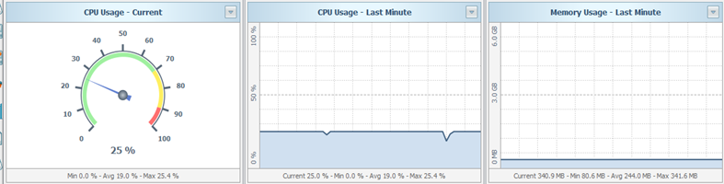

Figure 17: Below is the data while using 2 Web cameras for face recognition

## **Testing Experimentation**

The system creates the ID of each successful registered subject with their personal information such as name, and course when producing the dataset. For the testing the study used 6 subjects and registered their faces to the system. In the testing period the researcher check the speed and accuracy of the system. and let the subjects pass through the web camera to gather data on how fast the system can detect and recognize a moving subject.

Based on the results of the testing the system can detect and recognize a subject walking at a normal speed and walking in a hurry subjects running over the web camera are failed to be detected. These results show that the system is ideal for WMSU's security check where individuals who enter are required to stop for check-up.

The expected results of facial recognition testing are defined by these terms below.

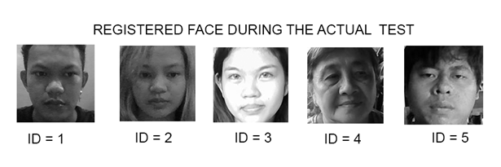

*Figure 18: Registered Face Used for Testing the System*

## **True Positive**

True positive occurs when a detected and recognized subject matches to the one that is available in the systems stored training dataset. The system will then show the information of that recognized subject; in this scenario the result is accurate.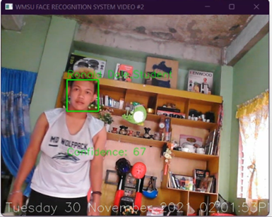

Figure 19: Sample of True Positive Occurrence

## **True Negative**

The true negative occurs when a subject’s dataset is not stored in the system's database and the system could not recognize the subject. The system will then show an "UNAUTHORIZED" notification that this result is accurate.

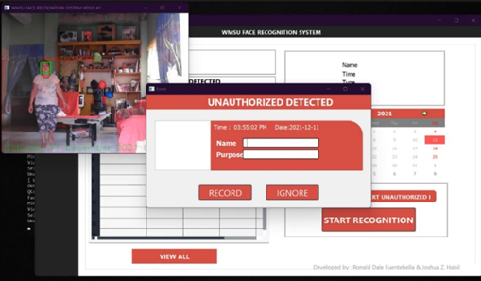

Figure 20: Sample of True Negative Occurrence

## **True Occlusion**

True occlusion happens when a subject's dataset is without occlusion. Occlusion in facial recognition means objects that might make facial recognition fail like wearing masks or helmets (ex. shades, glasses etc.) saved in the system's database and recognized subject matches to the one that is in the training dataset. The system will display the subject’s information and the result is accurate. (Refer to Testing the System with Change of Appearance.)

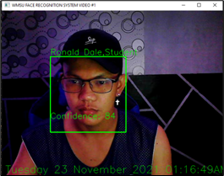

Figure 20: True occlusion.

## **Testing the System with Twins**

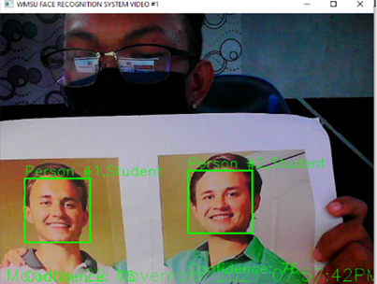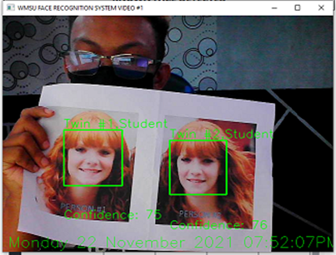

Ftigure 21: First Twin Sample Testing

The two figures above show a testing of the system with twins or subjects with identical facial looks. As observed from the testing the system still recognized which is which from these subjects. This is because the system is using LBPH algorithm which converts every subject’s facial dataset into a unique histogram for facial recognition.

This test gives good assurance and reliability of the system which shows that the system can still recognize and differentiate individuals with similar facial features and appearance such as twins.

## **Testing the System with Change of Appearance**

## 

Figure 22: Face Detection and Recognition with Occlusion

| Test Number | Change in Appearance | Lighting Condition | Confidence Level | Occlusion |
| --- | --- | --- | --- | --- |
| 1 | No Change | Artificial light | 89% | No occlusion |
| 2 | black eye makeup | Artificial light | 85% | make-up |
| 3 | With eye glasses | Artificial light | 83% | Eye glasses |
| 4 | With eye glasses and cap | Artificial light | 84% | Eye glasses and cap |
| 5 | With shades | Artificial light | 75% | shades |
| 6 | With shades but a bit far from camera | Artificial light | Undetectable | Shades but with distance from camera |

*Table 3: Face Detection and Recognition with Occlusion*

The testing results show that the system can still recognize individuals with minor changes in appearance, such as having a beard, blackened eye, or wearing eyeglasses and a cap, with a high confidence score of up to 89%. However, on test #5, where the subject is wearing a sunglass, the confidence level drops to 75% and with some minor changes in lighting conditions, the system has already failed to recognize the subject.

This demonstrates that the system is sufficiently adaptable and reliable to recognise faces with subtle changes in appearance. This data is advantageous since many people use facial accessories such as eyeglasses, which enables the system to identify individuals more efficiently.

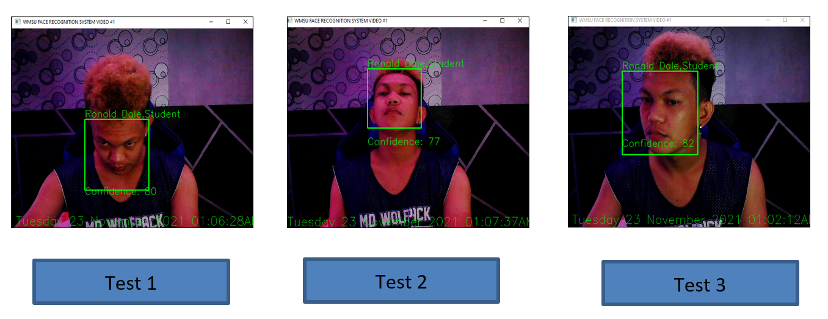

Table 4: Pose Variation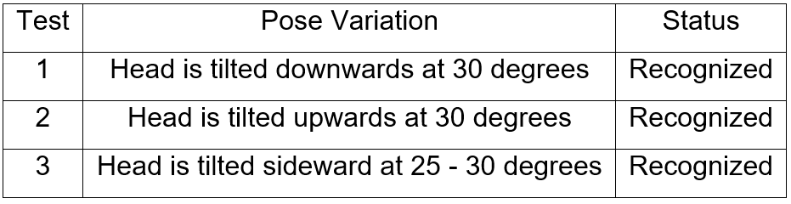

Three poses, as shown above, are used to test if the system can still detect and recognize the subject. Pose variation happens when the subject's position is at a different angle to the camera. Using three different pose angles, the system can still detect and recognize the subject but with a different confidence level depending on the angle of the face.

This test was conducted to give a better guide on how to angle and place the camera. As the test result shows, even though the Haar Cascade Classifier being used is for frontal-face detection, the system can still detect and recognize faces titled downward, upwards, and sideward up to 30 degrees.

## **Confidence Test**

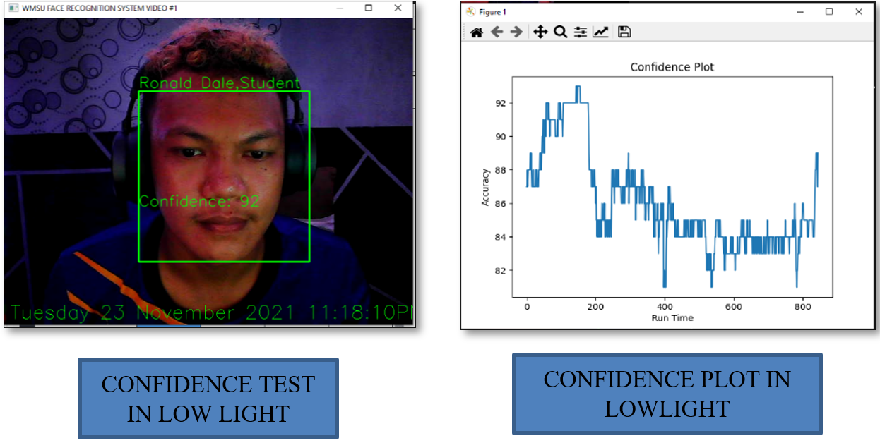

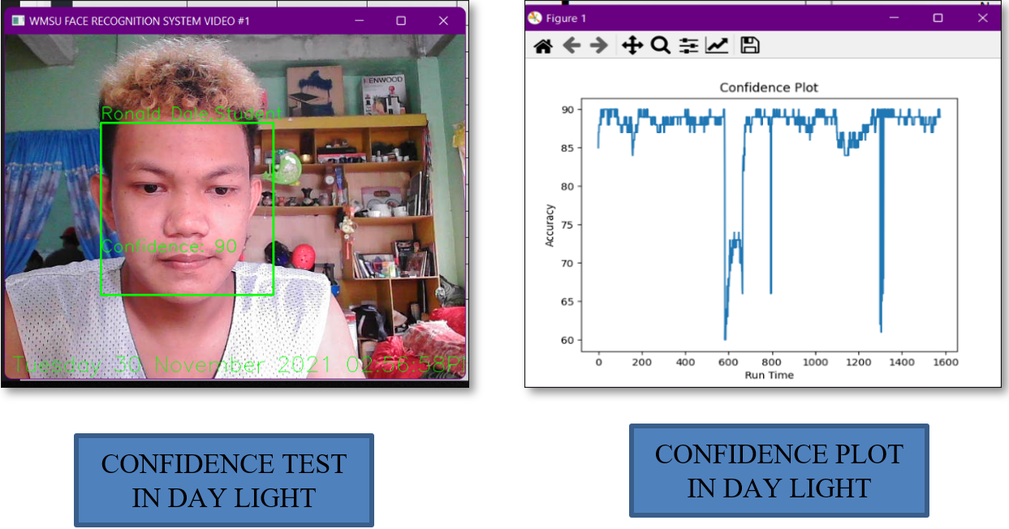

The figures above show the comparison of face recognition and detection during night time using artificial light and day time using natural light. Both tests show no difference at all in terms of recognition confidence rate. Confidence plot in lowlight registers a 92% highest confidence rate and 84% lowest confidence rate during the system's 800 seconds recognition runtime. Confidence plot in daylight registers a 90% highest confidence rate and 60% lowest confidence rate during the system's 1600 seconds recognition runtime.

The confidence test is conducted to show the difference between facial recognition during day time with natural light and night time with artificial light. The test comparison shows no difference at all as both tests resulted an acceptable facial recognition at 90% making the system functional and reliable at any lighting conditions as long as the face is clearly captured by the camera.

## **Testing the System Using Two Cameras Simultaneously**

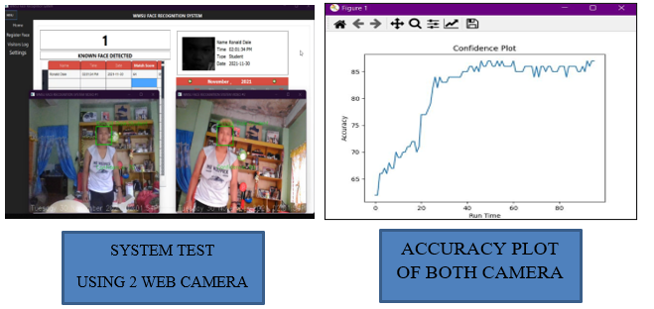

The system can detect a face with a maximum of 2 meters distance from the camera. The figures above show the testing of the system using two cameras simultaneously. This testing is done to determine if the system can run using more than one camera. During testing the system successfully recognizes the subject's face in both cameras. Accuracy plot shows that the system registers a 90% highest confidence rate and below 60% lowest confidence rate during the 100 seconds recognition runtime.

The test demonstration using two cameras is necessary to determine the capability and stability of the system using two cameras simultaneously. The result shows that the system is capable of using two cameras at the same time with no difference in its performance and stability as using one camera.

# 

# **CHAPTER V**

**CONCLUSIONS AND RECOMMENDATIONS**

**CONCLUSIONS**

Face recognition is a biometric solution designed for the purpose of recognizing a human face in a way that is less intrusive and requires no contact. Facial recognition technology is more suited to individuals who are unwilling to collaborate with other biometric identifying methods such as fingerprint, iris, or hand scan.

In this paper, the face recognition system is designed and developed using Haar Cascade Classifier and Local Binary Pattern Histogram. The developed system can store and enroll subjects' faces and information into the system easily, and the training process time for each new subject being registered only increases by 2-3 seconds, which makes the system training step very fast. It is also been verified that with 250 training images of each person being trained into the classifier it can achieve a confidence rate of up to 90% in a real-time video; The system also successfully identifies every unauthorized individual visible in the camera and has the ability to prompt the unauthorized personnel to log their entry, which makes it very effective in monitoring people in an organization or in school to provide better security; During the testing, the system was able to perform well in both higher light intensities, reaching up to a 92% confidence rate, and dark lighting, reaching 90%-92% confidence rate. This concludes that the proposed system can prove most beneficial to improving the existing security system.

## **RECOMMENDATION**

The design, implementation, and testing of a face recognition system are completed and the results of the tests indicate that the system performs satisfactorily, on the other hand , the system still has some future works for improvements, one of which is to improve the distance of recognition by implementing more advance algorithm , Another feature that would be beneficial in the future works would be an online server that has the ability to manage more than 2 cameras to better increase the security and effectiveness of the system, also in future works the implementation in full web-app base system would greatly help to increase its ease to use and to implement.

# **APPENDICES**

## **Appendix A Gantt Chart**

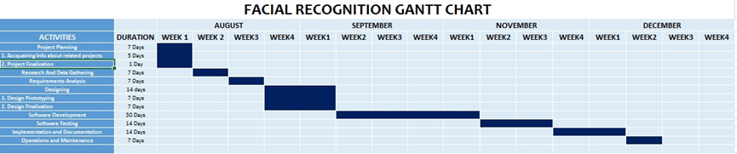

## **Appendix B Plagiarism Report**





## **Appendix C**

## **PROTOTYPE**



*Face Enrollment*

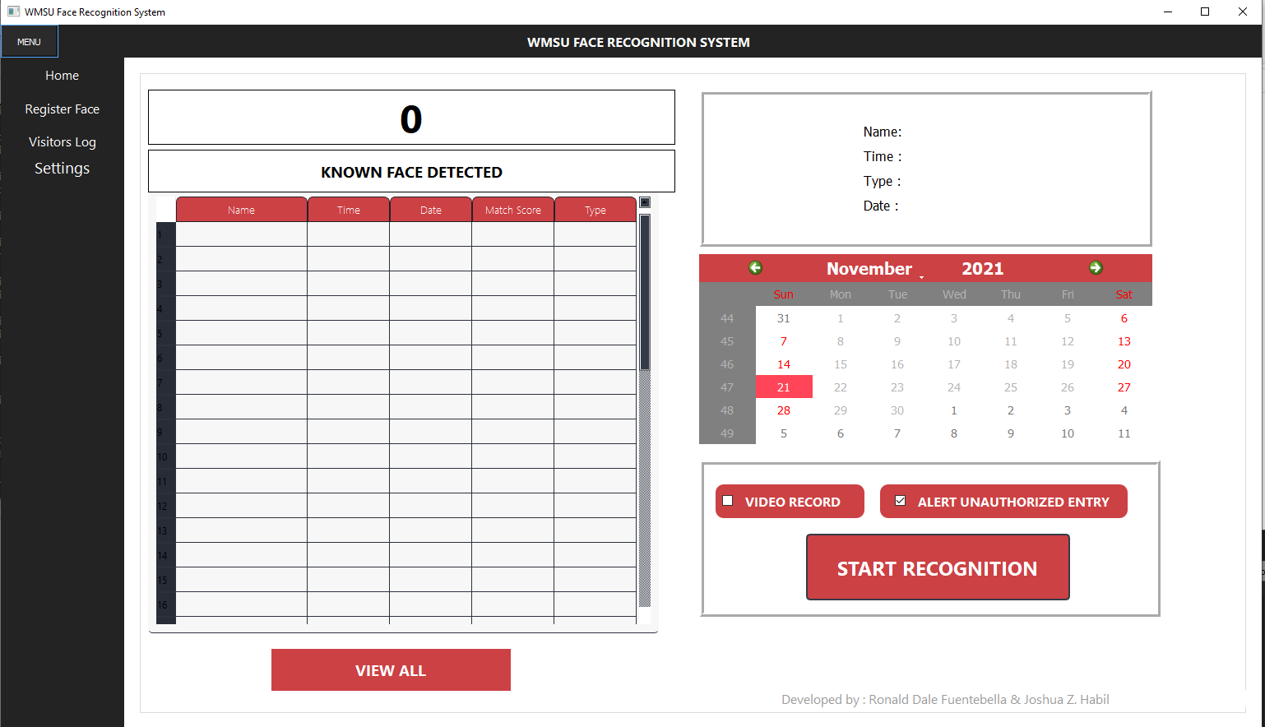

Desktop Application side Home Screen

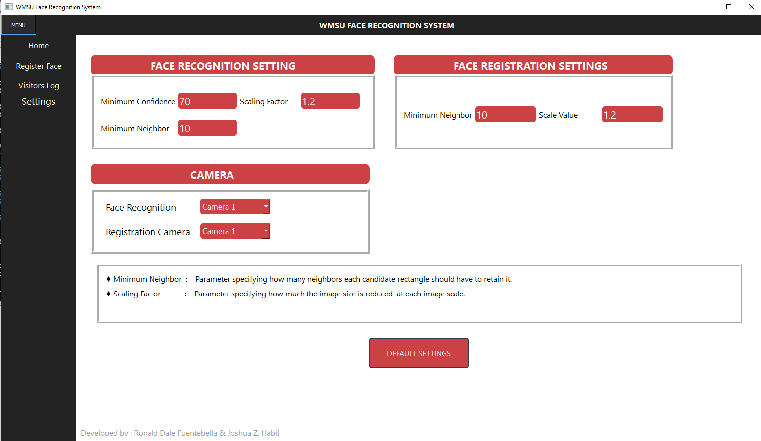

System Settings parameters



Admin log-in

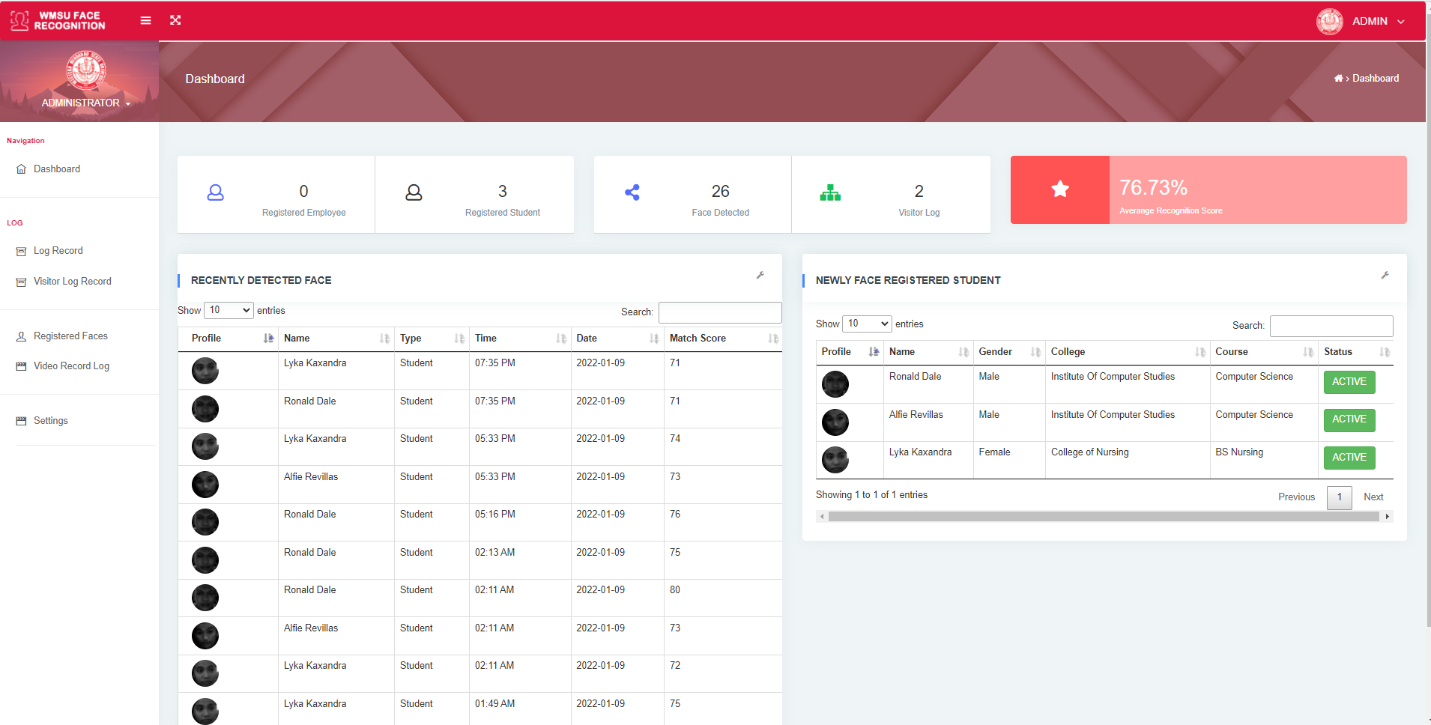

Admin | Dashboard

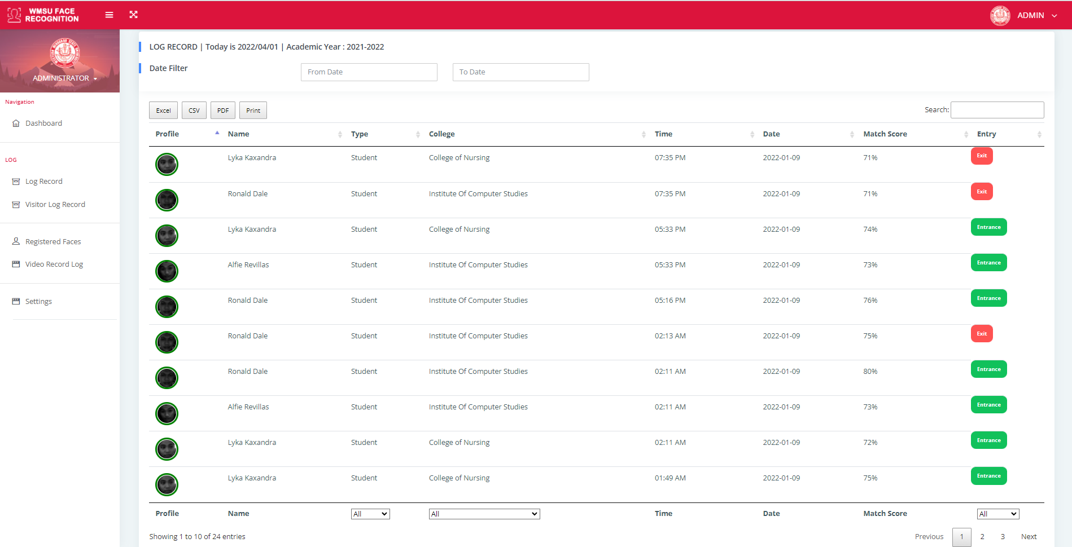

Admin | Known Face Log Record



Admin | Visitors Log Record

## 

Admin | Registered faces

## 



Admin | User Information

## 

Admin | Video Log Record

## 

## 

## **Appendix D**

## **Photo Documentation**

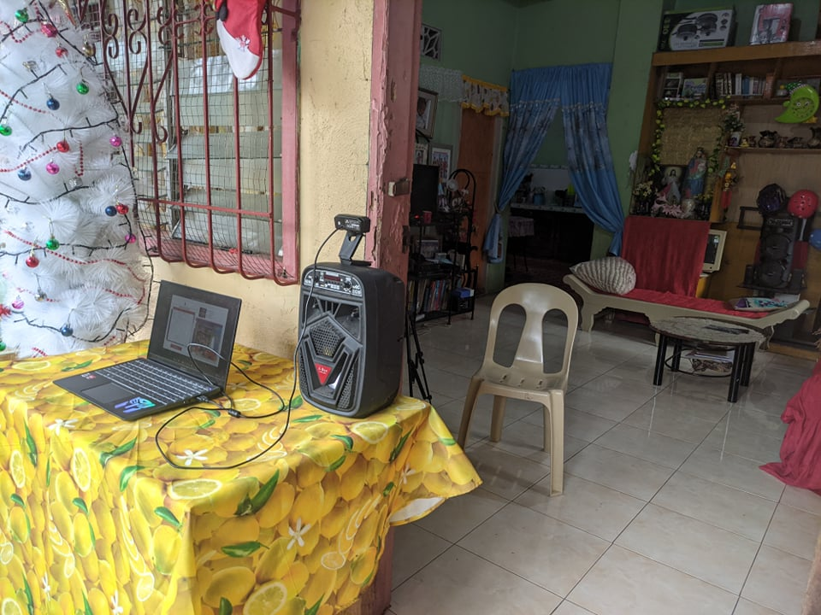

***Test Setup***

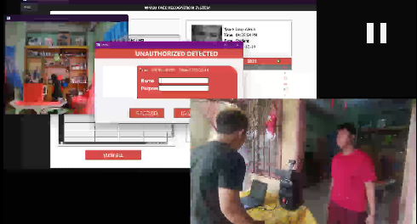

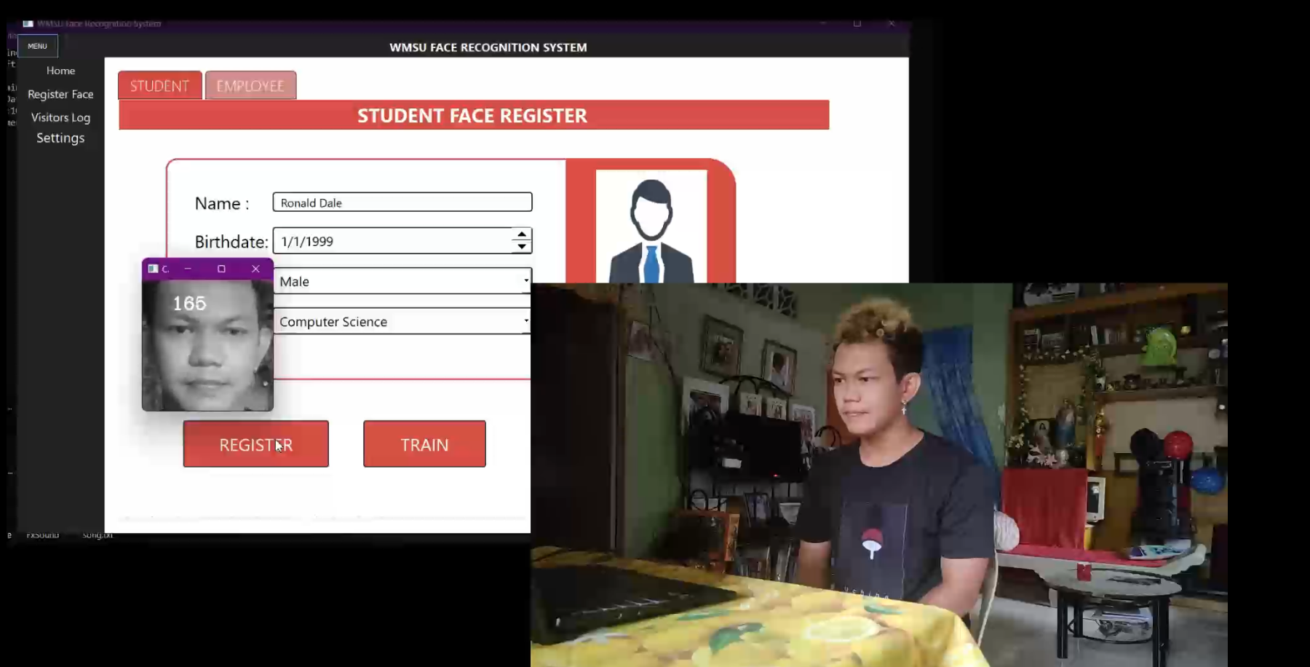

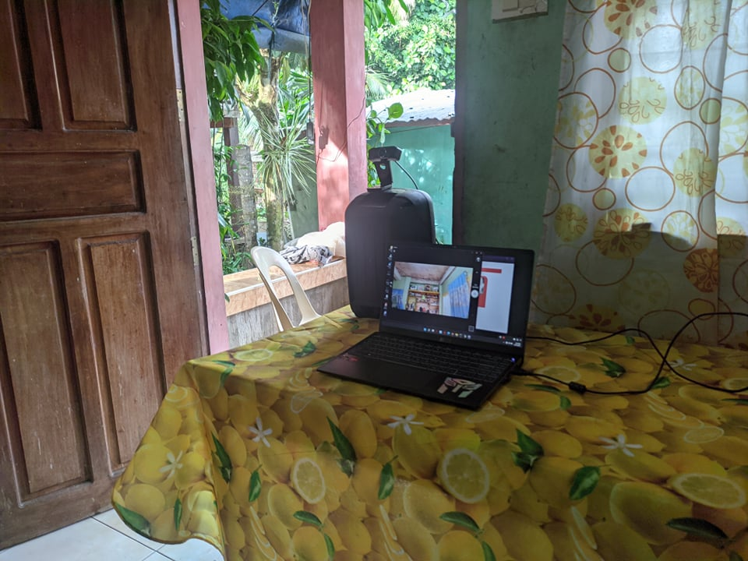

**Appendix E**

**User Manual**

**Facial Recognition System Interface**

Welcome to the very first facial recognition biometric system of Western Mindanao State University. The Facial recognition System eliminates the hassle of monitoring and logging entries to the school campus bringing ease for students, visitors, employees and staff of the school. The user manual provides a detailed description of the system's features. This manual will make sure that you'll find this system easy to use.

**System Navigation**

The main areas of the face recognition system are shown below and are described in detail in the following page.

* Home
* Register Face
* Visitor Log
* Settings

**FACE RECOGNITION DESKTOP APPLICATION USER INTERFACE**

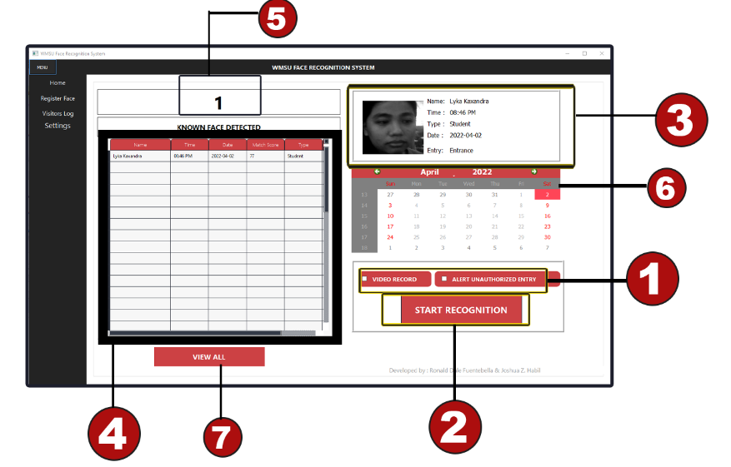

**Home Navigation Page**

This page shows the record of all registered faces detected by the system. Date and time of entry are recorded every time a registered face is detected. The system automatically recognizes the face of a registered subject and shows its personal information as well as creating a log record.

**[1]**  **Tick Video Record**

To record the session.

**[1] Tick Alert Unauthorized Entry**

To enable alert popup for detected unauthorized entry.

**[2] Click Start Recognition Button**

To open the selected camera and enable face recognition after gate selection.

**[3]** **Face Detected Information**

This section shows basic information like (name,type,entry,recognized time and date of entry) of the recognized subject .

**[4] Log Record Table**

A table that shows all the log record during the day with information such as name, time and date of entry, type, match score, and gate number entry.

**[5] Recognition Counter**

Shows the number of detected subjects during the day.

**[6] Calendar**

An up to date calendar to provide user an ease of checking the date.

**[7] Click View All Button**

To expand the log record table and view all recognized subjects during the day.

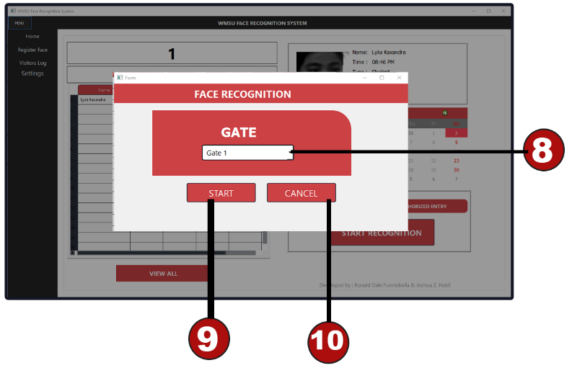

After click the start recognition button ; a popup will appear promting user to

Select which gate is the client located.

**[8]** **Gates - To** select which gate to start the face recognition system

**[9] Start**

To start face recognition in the selected gate.

**[10] Cancel**

To cancel face recognition.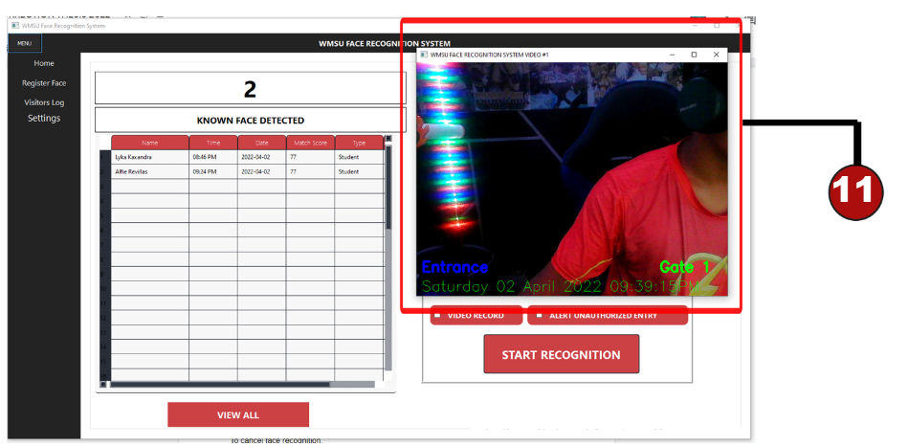

**[11] Face Recognition Live Stream Window**

Show a live video stream of the subjects providing information such as gate number entry, date of entry, and time of entry.

**Register Face Navigation Page**

This page is where the registration occurs. There are two types of clients; student and staff or employee. Every type has different information that needs to be imputed upon registration.

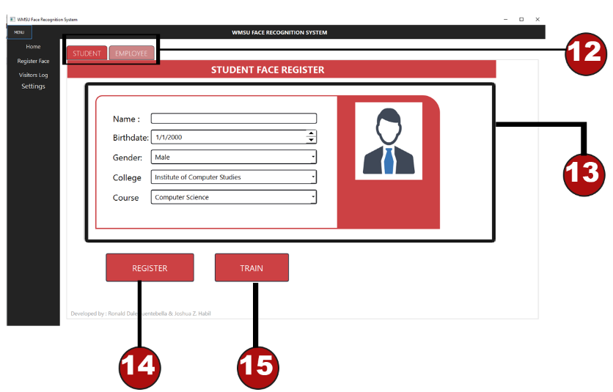

**[12] Subject selection tab (Student,Employee/staff)**

To select the type of subject.

**[13] Required information for registration and training**

To input information for subject enrollment in the system.

**[14] Click Register Button**

To register a subject in the system. All fields in [13] must be filled up. The client (ex. Student, staff or employee) stands in front of the web camera with a clear view of their face for registration and the registration process will begin. The process will be completed within a few seconds, approximately not more than 5 seconds.

**[15] Click Train Button**

To train the captured images of the registered subject and store it in the system.

**Visitors Log Navigation Page**

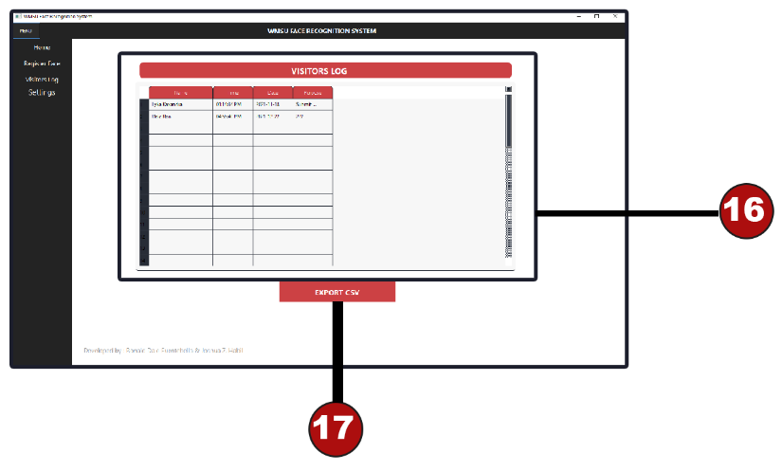

**[16] Visitors Log Table**

A table that shows the log record of visitors that are not registered in the system. The table have important information about the visitor such as name, time of entry, date of entry, and purpose.

**[17] Click Export Button**

To download or export the log record into a printable file.

**Settings Navigation Page**

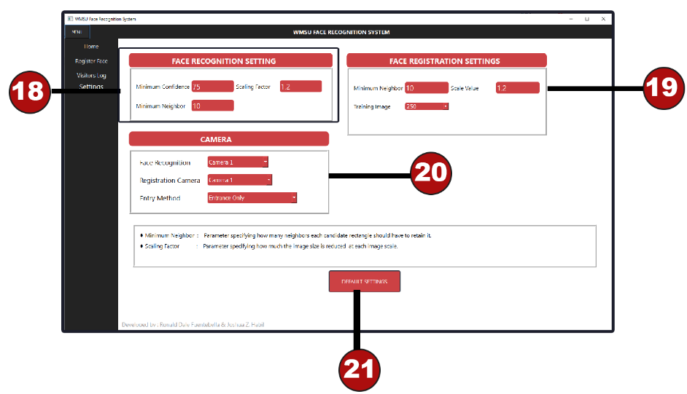

**[18] Face Recognition settings #1**

* **Minimum confidence** - the minimum confidence score number from 0 to 100 that represents the likelihood that the prediction of the subject face is true.
* **Minimum Neighbor** - It is a threshold value that specifies how many neighbors each rectangle should have in order for it to be marked as true positive. In other words, let’s assume that each iteration marks certain rectangles (i.e. classifies a part of the image as a face). Now, if the subsequent iterations also mark the same areas as a positive, it increases the possibility of that rectangle area to be a true positive. If a certain area is identified as a face in one iteration, but not in any other iteration, they are marked as false positives. In other words, minNeighbors is the minimum number of times a region has to be determined as a face.
* **Scale Factor -** The smaller the value of scaleFactor, greater the accuracy and higher the computation expenses.

**[20] Camera settings :**

* **Camera Selection -** choose which camera to use (Camera 1 , Camera 2 or Both 1 & 2).
* **Registration Camera –** choose what camera to use during face enrollment or subject registration.
* **Entry Method -** Choose whether to enable face recognition in entrance only or both entrance and exit of the campus gate.

**[21] Default Settings -** Will revert back to the developer recommended settings.